 | נושא | תמונה |  | זכויות
1 | الخلفية التاريخية  لإقامة الدولة  רקע היסטורי להקמת המדינה | 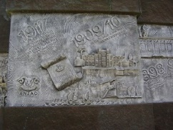 |  | צילום:ד"ר אבישי טייכר, CC BY 2.5 <https://creativecommons.org/licenses/by/2.5>, via Wikimedia Commons  https://www.pikiwiki.org.il/gallery/?sort=&s=&method=exact&tags=&topic=&image-id=9699&from-year=&to-year=&author=&contributor=&organization=
2 | اعلان وثيقة الاستقلال  מסמך הכרזת המדינה | 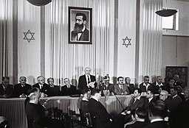 |  | https://commons.wikimedia.org/wiki/File:Declaration_of_State_of_Israel_1948.jpg
3 | مبدأ حكم اشعب  אנשים שולטים בעקרון | 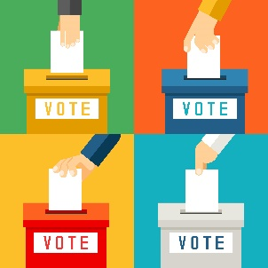 |  | <a href='https://www.freepik.com/vectors/hand'>Hand vector created by macrovector - www.freepik.com</a>  https://www.freepik.com/free-vector/hand-putting-voting-paper-ballot-box-referendum-polling-choice-voter_10602410.htm#page=2&query=vote&position=0
4 | المفاهيم الديموقراطية الليبرالية  מושגים דמוקרטים ליברליים | 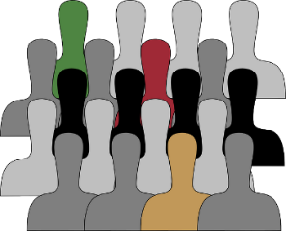  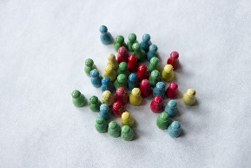 |  | Image by <a href="https://pixabay.com/users/clker-free-vector-images-3736/?utm_source=link-attribution&amp;utm_medium=referral&amp;utm_campaign=image&amp;utm_content=296570">Clker-Free-Vector-Images</a> from <a href="https://pixabay.com/?utm_source=link-attribution&amp;utm_medium=referral&amp;utm_campaign=image&amp;utm_content=296570">Pixabay</a>  Image by <a href="https://pixabay.com/users/metsikgarden-4421146/?utm_source=link-attribution&amp;utm_medium=referral&amp;utm_campaign=image&amp;utm_content=3207592">MetsikGarden</a> from <a href="https://pixabay.com/?utm_source=link-attribution&amp;utm_medium=referral&amp;utm_campaign=image&amp;utm_content=3207592">Pixabay</a>
5 | ثقافة سياسية ديموقراطية  תרבות פוליטית דמוקרטית | 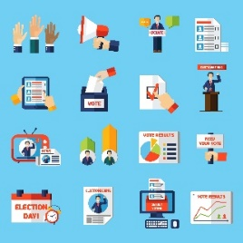 |  | <a href='https://www.freepik.com/vectors/people'>People vector created by macrovector_official - www.freepik.com</a  >  https://www.freepik.com/free-vector/elections-voting-flat-icons-set_4431057.htm#query=democracy&position=23
6 | مبدأ حسم الأكثرية والحفاظ على حقوق الأقلية  העיקרון של החלטת הרוב ושמירה על זכויות המיעוט | 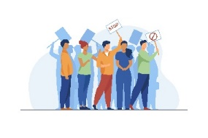 |  | <a href='https://www.freepik.com/vectors/people'>People vector created by pch.vector - www.freepik.com</a  >  https://www.freepik.com/free-vector/activists-protest-meeting-crowd-people-with-placards-standing-together-flat-vector-illustration-protesters-society-concept_10606150.htm#query=democracy&position=29
7 | حقوق الانسان والمواطن  זכויות אדם ואזרח | 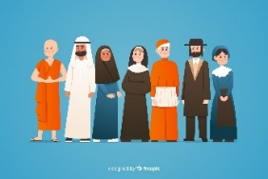 |  | https://www.freepik.com/free-vector/flat-multiracial-group-people_5096789.htm#page=1&query=religion&position=0
8 | واجبات الانسان كانسان وواجبات الانسان كمواطن  חובות אנושיות כאדם וחובות אנוש כאזרח | 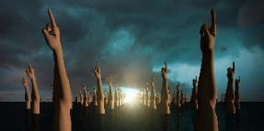 |  | Image by <a href="https://pixabay.com/users/8385-8385/?utm_source=link-attribution&amp;utm_medium=referral&amp;utm_campaign=image&amp;utm_content=3332802">Reimund Bertrams</a> from <a href="https://pixabay.com/?utm_source=link-ttribution&amp;utm_medium=referral&amp;utm_campaign=image&amp;utm_content=3332802">Pixabay</a>
9 | التوجهات الاقتصادية الاجتماعية في الدولة الديموقراطية  מגמות חברתיות – כלכליות במדינה דמוקרטית |     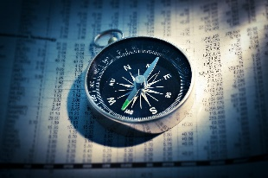 | Image by <a href="https://pixabay.com/users/alexas_fotos-686414/?utm_source=link-attribution&amp;utm_medium=referral&amp;utm_campaign=image&amp;utm_content=2852375">🎄Merry Christmas 🎄</a> from <a href="https://pixabay.com/?utm_source=link-attribution&amp;utm_medium=referral&amp;utm_campaign=image&amp;utm_content=2852375">Pixabay</a  >  Image by <a href="https://pixabay.com/users/geralt-9301/?utm_source=link-attribution&amp;utm_medium=referral&amp;utm_campaign=image&amp;utm_content=384743">Gerd Altmann</a> from <a href="https://pixabay.com/?utm_source=link-attribution&amp;utm_medium=referral&amp;utm_campaign=image&amp;utm_content=384743">Pixabay</a  >  Image by <a href="https://pixabay.com/users/absolutvision-6158753/?utm_source=link-attribution&amp;utm_medium=referral&amp;utm_campaign=image&amp;utm_content=2779371">Gino Crescoli</a> from <a href="https://pixabay.com/?utm_source=link-attribution&amp;utm_medium=referral&amp;utm_campaign=image&amp;utm_content=2779371">Pixabay</a>
 | العولمة  גלובליזציה |  |  | <a href='https://www.freepik.com/vectors/background'>Background vector created by rawpixel.com - www.freepik.com</a>
11 | تقييد السلطة  הגבלת סמכות |  |  | <a href='https://www.freepik.com/photos/wood'>Wood photo created by Racool_studio - www.freepik.com</a>
12 | مبدأ سلطة القانون  עקרון שלטון החוק |   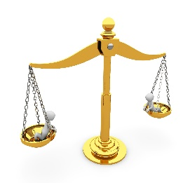 |  | <a href='https://www.freepik.com/photos/wood'>Wood photo created by Racool_studio - www.freepik.com</a>  Image by <a href="https://pixabay.com/users/peggy_marco-1553824/?utm_source=link-attribution&amp;utm_medium=referral&amp;utm_campaign=image&amp;utm_content=1010917">Peggy und Marco Lachmann-Anke</a> from <a href="https://pixabay.com/?utm_source=link-attribution&amp;utm_medium=referral&amp;utm_campaign=image&amp;utm_content=1010917">Pixabay</a>
13 | الامن والديموقراطية  ביטחון ודמוקרטיה |  |  | Image by <a href="https://pixabay.com/users/hurca-8968775/?utm_source=link-attribution&amp;utm_medium=referral&amp;utm_campaign=image&amp;utm_content=3502287">Mirko Grisendi</a> from <a href="https://pixabay.com/?utm_source=link-attribution&amp;utm_medium=referral&amp;utm_campaign=image&amp;utm_content=3502287">Pixabay</a>
14 | الفكرة القومية  הרעיון הלאומי | 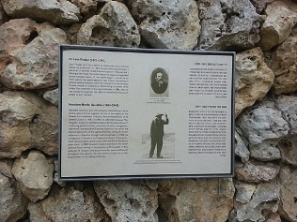 |  | יעל י, CC BY-SA 3.0 <https://creativecommons.org/licenses/by-sa/3.0>, via Wikimedia Commons
15 | الطابع المنشود لدولة إسرائيل  האופי הרצוי של מדינת ישראל | 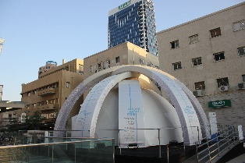 |  | Beko, CC BY-SA 4.0 <https://creativecommons.org/licenses/by-sa/4.0>, via Wikimedia Commons
16 | المميزات اليهودية لدولة إسرائيل  המאפיינים היהודיים של מדינת ישראל | 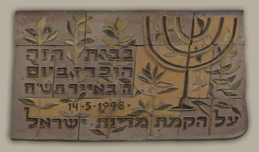  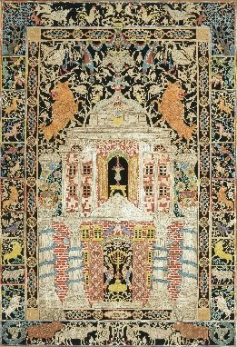 |  | Eva Samuel, CC BY-SA 3.0 <https://creativecommons.org/licenses/by-sa/3.0>, via Wikimedia Commons  Jewish Museum, Public domain, via Wikimedia Commons
17 | دولة اسرائيل والشعب اليهودي في الشتات  מדינת ישראל והעם היהודי בגולה | 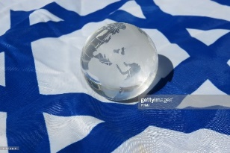 |  | https://www.gettyimages.com/detail/photo/israel-and-the-world-royalty-free-image/513756934?utm_medium=organic&utm_source=google&utm_campaign=iptcurl
18 | الأقليات في إسرائيل  מיעוטים בישראל |  |  | https://www.freepik.com/free-photo/different-pieces-puzzle-arrangement_9727653.htm
19 | التصدع القومي  קרע לאומי | 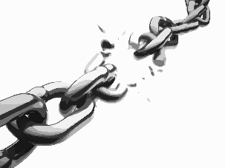 |  | Image by <a href="https://pixabay.com/users/clker-free-vector-images-3736/?utm_source=link-attribution&amp;utm_medium=referral&amp;utm_campaign=image&amp;utm_content=297842">Clker-Free-Vector-Images</a> from <a href="https://pixabay.com/?utm_source=link-attribution&amp;utm_medium=referral&amp;utm_campaign=image&amp;utm_content=297842">Pixabay</a>
20 | الأسس الدستورية  יסודות חוקתיים | 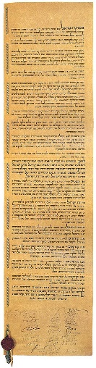 |  | https://he.wikipedia.org/wiki/%D7%9E%D7%92%D7%99%D7%9C%D7%AA_%D7%94%D7%A2%D7%A6%D7%9E%D7%90%D7%95%D7%AA#/media/%D7%A7%D7%95%D7%91%D7%A5:Israel_Declaration_of_Independence.jpg  מאת לא ידוע - לא ידוע, נחלת הכלל, https://commons.wikimedia.org/w/index.php?curid=3569169
21 | الثورة الدستورية  המהפכה החוקתית | 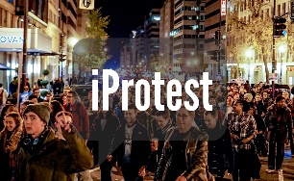 |  | יוצר: Ted Eytan  זכויות יוצרים  : This material is licensed to the public under the Creative Commons Attribution-ShareAlike 4.0 International License http://creativecommons.org/licenses/by-sa/4.0/‏
22 | السلطة التشريعية  בית המחוקקים | 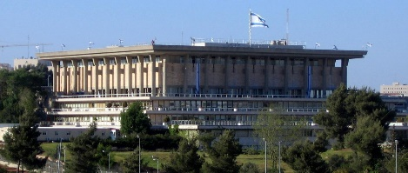 |  | https://he.wikipedia.org/wiki/%D7%A8%D7%A9%D7%95%D7%AA_%D7%9E%D7%97%D7%95%D7%A7%D7%A7%D7%AA#/media/%D7%A7%D7%95%D7%91%D7%A5:Knesset_Building_(South_Side).JPG
23 | السلطة التنفيذية  רשות מבצעת | 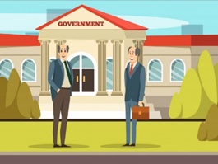 |  | https://www.freepik.com/free-vector/colored-municipal-buildings-composition_6228990.htm#page=1&query=Government&position=2
24 | السلطة القضائية  מערכת משפטית |  |  | https://www.freepik.com/free-vector/protesting-women-fighting-rights_9650714.htm#page=1&query=demonstration&position=14
25 | عنقود الانتخابات والأحزاب  בחירות ואשכל מפלגות | 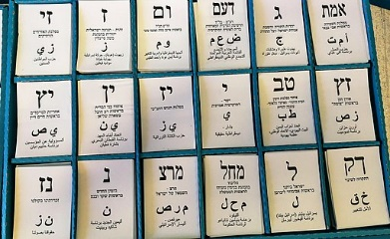 |  | Laliv g, CC BY-SA 4.0 <https://creativecommons.org/licenses/by-sa/4.0>, via Wikimedia Commons
26 | عنقود مشاركة المواطنين والرقابة على سلطات الحكم  אשכול השתתפות אזרח ופיקוח על סמכויות הממשל |   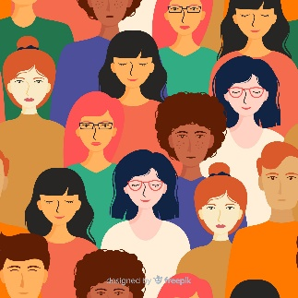 |  | https://www.freepik.com/free-vector/protesting-women-fighting-rights_9650714.htm#page=1&query=demonstration&position=14  <a href='https://www.freepik.com/vectors/background'>Background vector created by freepik - www.freepik.com</a>
27 | عنقود الحكم المحلي  אשכול השלטון המקומי | 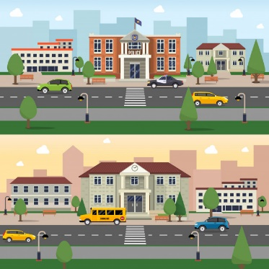 |  | https://www.freepik.com/free-vector/municipal-buildings-banner_2875655.htm#page=1&query=city%20hall&position=6
28 | مصطلحات مركزية في المدنيات  מונחים מרכזיים באזרחות |  |  | https://www.freepik.com/premium-vector/open-book-hand-with-magnifying-glass_8413520.htm#page=1&query=dictionary&position=37
29 | امتحانات بجروت وحلول  בחינות ופתרונות |  |  | https://www.freepik.com/free-vector/hand-drawn-checklist-background_3903465.htm#page=1&query=tests&position=3
 |  |  |  | Image by <a href="https://pixabay.com/users/gdj-1086657/?utm_source=link-attribution&amp;utm_medium=referral&amp;utm_campaign=image&amp;utm_content=2730338">Gordon Johnson</a> from <a href="https://pixabay.com/?utm_source=link-attribution&amp;utm_medium=referral&amp;utm_campaign=image&amp;utm_content=2730338">Pixabay</a>

